***PARCC Readiness District Toolkit***

 

**Contents**

I. Introduction 3

Purpose of this Toolkit 3

Readiness Toolkit Components 3

How the Toolkit Works 4

What is Necessary to Use this Toolkit? 6

The Relationship Between PARCC Readiness and Instructional Technology Readiness 6

Responsibility Readiness Worksheet 8

II. PARCC Technology Guidelines, Capacity Planning Tool and CBT Human Factors Guide 10

PARCC Guidelines 10

PARCC Capacity Planning Tool 11

Refer to the Responsibility Readiness worksheet for the names of those individuals who have this information. 11

LHRIC CBT Human Factors Guide 11

Assistance in Gathering Data and Completing the Forms 12

III. The District Readiness Gap Analysis Report 13

V. Attachments/Appendices 14

# I. Introduction

## Purpose of this Toolkit

The [Common Core State Standards Initiative](http://www.corestandards.org/) promises to bring sweeping changes to how students learn and teachers teach. The curriculum-based aspects of the Common Core relate to providing students with opportunities to meet world-class standards for developing thinking, learning, and creativity skills. For teachers, the work to implement and create the learning environments necessary for meeting the standards brings to the fore issues of moving curriculum, instruction, and assessment fully into the 21st century. Perhaps nowhere is this movement more obvious than in the fact that the new Common Core assessments scheduled to replace existing state-standardized tests starting in [SY2014](http://www.engageny.org/sites/default/files/resource/attachments/ccsstimeline.pdf) will fully utilize computer-based testing (CBT). CBT will allow states, districts, teachers, parents, and of course students to quickly and efficiently access assessment data and to thereby quickly fine-tune learning in a way that is not possible with traditional paper and pencil tests.

But just as the Common Core challenges teachers to develop and deploy new instructional practices to meet new standards, the CBT component of the Common Core challenges districts to deploy a sufficient level of technology infrastructure to support the new assessments. While this infrastructure is really little different than what most districts have been aiming for in terms of student access to instructional technology for day-to-day use, the intense network bandwidth and nearly one-to-one student to device ratios required for Common Core testing put districts to the test of whether or not they have truly developed a technology infrastructure that is ready for 21st century learning. Simply put, is your district ready to deploy the new Common Core assessments?

In New York, the new assessments are commonly referred to as [PARCC](http://www.parcconline.org/) assessments. This is due to the fact that NY is participating in the PARCC consortium of states for the development of Common Core assessments. PARCC has published a set of guidelines detailing the technology requirements related to its assessments. This toolkit is intended to help districts understand the requirements and then to conduct the necessary tests to determine technology readiness. Finally, the toolkit provides resources for districts to aggregate and describe what they need to reach readiness. This description is useful in working with the funding agents and vendors that will ultimately help districts acquire the technology infrastructure necessary for PARCC’s computer based testing.

## Readiness Toolkit Components

The Lower Hudson Regional Information Center ([LHRIC](http://www.lhric.org)) in partnership with Sun Associates has created this Readiness Toolkit which contains the following components:

[Readiness Responsibility Worksheet](link) – This simple worksheet helps districts assign responsibility for various aspects of readiness preparation and to create a timeline for the readiness review process.

[PARCC Technology Guidelines](http://www.parcconline.org/sites/parcc/files/PARCCTechnologyGuidelines2dot1_Feb2013Update.pdf) – PARCC has prepared a set of guidelines that describe the hardware, software, and network bandwidth necessary to administer the assessments to the level of the student desktop. These guidelines form the basic infrastructure readiness indicators for this toolkit.

[PARCC Capacity Planning Tool](http://www.parcconline.org/sites/parcc/files/PARCCCapacityPlanningTool_3-5-13FINAL4-12-13.xlsx) – PARCC has created an interactive tool that takes district data on guideline-compliant devices, bandwidth, and testing conditions (days, numbers of students, etc.) and then compares this data to the PARCC Guidelines. The result of this comparison is a quantitative report on device and bandwidth adequacy.

[CBT Human Factors Guide](link) – LHRIC has created a set of guidelines for describing and addressing the issues related to staffing, scheduling, etc. necessary for administering the assessments.

[LHRIC District Readiness Gap Analysis Report](link) – This LHRIC-created report template aggregates and summarizes the data that flows from the Capacity Planning Tool and Human Factors Guide. Completing this template-driven report provides districts with a way to organize and present their data findings (gaps) in a “proposal” that goes to Boards/district administrators and explains what a district needs to do to reach full readiness.

While the tools in this toolkit can be used as stand-alone items, it is intended that the tools be used within the context of technical assistance provided by LHRIC. How this technical assistance fits in with the various tools and templates is described in the graphic, below.

## How the Toolkit Works

The Readiness Toolkit is a combination of guidelines, interactive tools, and LHRIC technical assistance that provides districts with a guided approach to discovering their degree of readiness and then developing solutions for reaching full readiness to implement the PARCC assessments.

Technical assistance is a key component of the toolkit. Depending on individual district preference, LHRIC offers the following technical assistance opportunities related to the use of the Readiness Toolkit.

* Assistance to a district in gathering infrastructure, testing, and human factors data and then inputting that data into the various components of the toolkit. This assistance is scheduled through communication with your district’s LHRIC Regional Coordinator. Typically, districts that have gathered their internal data will need less than one day of LHRIC technical assistance in completing the tools.
* Assistance to a district in completing the Readiness Gap Analysis Report. Once a district has completed the Capacity Planning and Human Factors tools, the results from these tools can be migrated into a report. The toolkit has provided a template for this report. LHRIC offers assistance to districts in completing the report template and in customizing the report for presentation to district funding authorities (in the event that the district needs to purchase additional resources to reach a state of readiness). This technical assistance is scheduled through communication with your district’s LHRIC Regional Coordinator.
* Assistance to a district in investigating and purchasing additional resources. This assistance is entirely optional, but it may be helpful to have assistance in exploring how RIC or BOCES services (including various CO-SERs) can help your district address gaps in readiness.

The following graphic illustrates the process for using the LHRIC PARCC Readiness Toolkit.

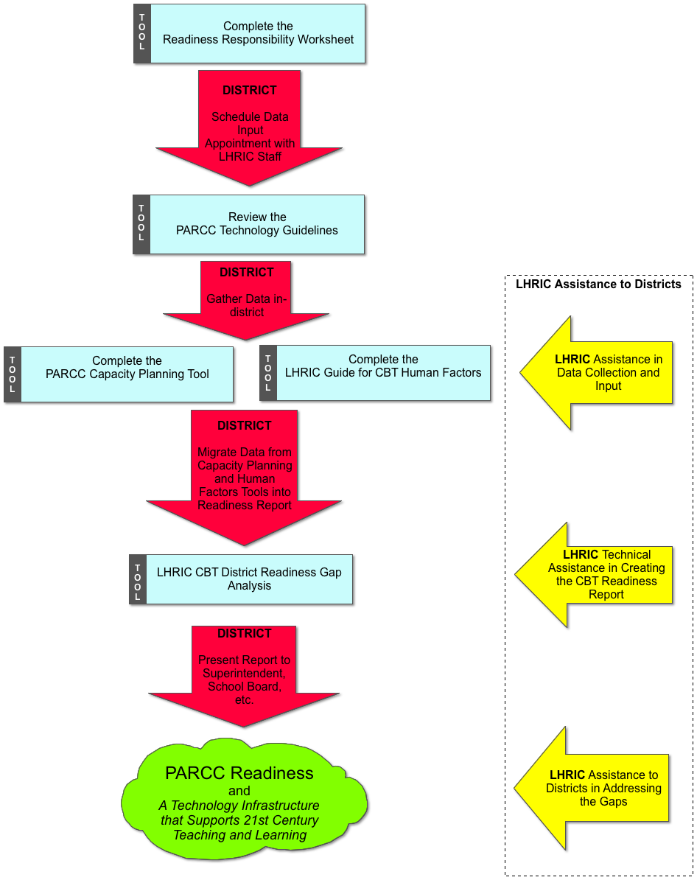

## What is Necessary to Use this Toolkit?

Even though LHRIC is committed to providing all possible assistance to its member districts in using this toolkit to investigate, describe, and address PARCC readiness, it remains necessary for districts to provide the following inputs into the toolkit-use process.

The district needs to designate a staff contact to work with the tools and LHRIC technical assistance providers. This district staff must be someone who has the ability to

* Acquire district technical data – e.g., device counts/inventory, information on device capability/configuration, network bandwidth information, software/network application use within the district, and technical staffing levels. Typically, a district technology coordinator has this information or can gather it.
* Represent the district’s intentions around test administration – e.g, someone on staff who has examined student testing requirements and who can speak to how these requirements are being articulated within the district. Issues such as grades and subjects to be tested and days allocated to testing each school year fall into this category of information.
* Speak to the district’s budget and budgeting process – This would be someone who understands the district’s budget process as well as the current and anticipated budgets. This is important in terms of accurately framing budget requests and/or fitting requests for new and additional resources (both technical and staffing) into the existing budget.

Designation of these staff, as well as a timeline for their input and work will be documented in the [Readiness Responsibility Worksheet](link).

## The Relationship Between PARCC Readiness and Instructional Technology Readiness

PARCC is just one component of a broader movement to implement the Common Core standards. Further, the Common Core is part of a still-broader movement to transform the teaching and learning environment in schools. While getting ready for PARCC is a significant undertaking and requires specific allocation of resources, it is important to remember that what all of this is about is something much more far-reaching than just having sufficient technical infrastructure for computer-based testing. The technical resources that enable PARCC testing have much more value than that which they will be put towards for perhaps 20 days of your school year. That value is found in the district’s ability to leverage its improved technical infrastructure for truly transformative instructional practices and what could be a truly 21st century learning environment…and environment that is usable 365 days of the year.

We feel that it is important that districts both articulate and plan for how improved technical infrastructure supports an enhanced teaching and learning environment. In fact, some of this explanation could be critical for building the community support necessary to reach PARCC readiness. Therefore, the process of planning for PARCC readiness should parallel (if not exist as a fully integrated component of) a process for investigating and planning for instructional technology readiness.

Investigating and planning for instructional technology readiness is a process that includes most of the same steps required for investigating and planning for PARCC readiness, only with different tools focused on different people and different data. Instructional technology readiness focuses on collecting data on curriculum, instructional practice, and professional development. The goal of an instructional technology readiness investigation is to determine the extent to which teachers and students are participating in the sorts of technology-infused learning practices that support the acquisition of Common Core (21st century) skills. Once current levels of readiness are determined, the district can proceed to plan on how it will work to close gaps between current practice and desired practice/outcomes. The result of this work is usually a strategic technology plan, of which an infrastructure plan (the product of the PARCC readiness work) is just a component.

LHRIC urges districts to make the connections between PARCC readiness and the broader issue of instructional technology readiness in its rationale for acquiring the technology resources necessary for PARCC readiness. The District Readiness Gap Analysis Report tool helps districts roughly frame these connections and provides the links to what should ideally be a comprehensive instructional technology plan.

**Now…**

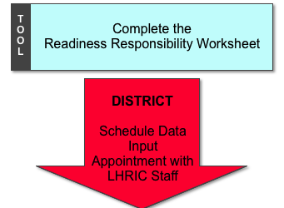

## Responsibility Readiness Worksheet

Dave2:Users:jeffsun:Desktop:readiness respon wksht.pdf

**Now…**

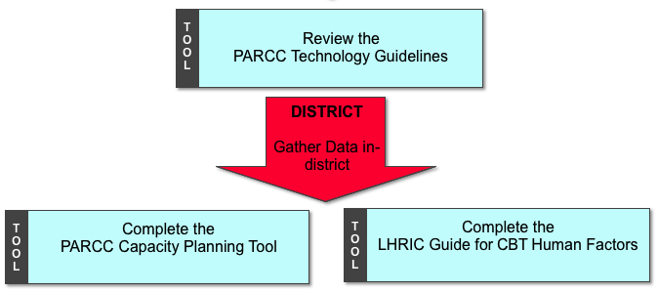

# II. PARCC Technology Guidelines, Capacity Planning Tool and CBT Human Factors Guide

***The guidelines and resources associated with school district readiness for Common Core assessment are constantly evolving. Therefore districts are urged to consult with LHRIC, NYSED, and other up-to-the-minute sources of information related to the Common Core and its assessment. The various guidelines and tools that follow are the most current available at the time of publication.***

## PARCC Guidelines

PARCC has published guidelines for the minimum requirements for computer-based assessment related to the PARCC Common Core tests. These guidelines are attached in the Appendix of this toolkit and are also available online at <http://www.parcconline.org/technology>.

The guidelines specify:

* Which devices students can use to participate in the PARCC online assessments
* The amount of bandwidth required to administer the online assessments concurrent with existing district bandwidth needs
* Which WWW browsers are compatible with the PARCC assessment site

Please note that PARCC will continue to update the device and bandwidth guidelines as they are refined through field tests and the test developers. Furthermore, it is possible that state departments of education (e.g., NYSED) will issue guidance on local interpretation of the guidelines. Districts should consult the [PARCC Technology website](http://www.parcconline.org/technology) and normal sources of information on state guidelines. **LHRIC staff will also work with districts to keep abreast of any changes in the current guidelines**.

## PARCC Capacity Planning Tool

The PARCC Capacity Planning tool is an interactive spreadsheet that allows districts to calculate the degree to which their devices and bandwidth are capable of meeting the PARCC technology guidelines. PARCC has made the following resources available to districts:

* [Capacity Planning Tool Spreadsheet](http://www.parcconline.org/sites/parcc/files/PARCCCapacityPlanningTool_3-5-13FINAL4-12-13.xlsx)
* [Capacity Planning Tool Print Version](http://www.parcconline.org/sites/parcc/files/PARCCCapacityPlanningTool_3-5-13_Printablev1.0.pdf)
* [Capacity Planning Tool Example](http://www.parcconline.org/sites/parcc/files/SmallElemExamplePARCCCapacityPlanningTool_3-5-13_Printablev1-1.pdf)
* [Assessment Administration Capacity Planning Tool Users’ Guide](http://www.parcconline.org/sites/parcc/files/UserGuideforAssessmentAdministrationCapacity%20PlanningTool_FINAL.pdf)

In order to complete the capacity planning tool, you will need to have the following information in-hand.

* Information on what grades your district intends to test in the upcoming school year (using the new PARCC CBI assessments)
* Number of days that your district intends to use to administer tests (the PARCC tool assumes a maximum of 20 days)
* Number of computer devices that meet or exceed the PARCC guidelines (see above)
* Information on raw available network bandwidth available at the school level
* Information on existing usage of bandwidth for various instructional and administrative uses (concurrent with testing on testing days)

## Refer to the Responsibility Readiness worksheet for the names of those individuals who have this information.

## LHRIC CBT Human Factors Guide

The CBT Human Factors Guide is a simple checklist and information recording form that helps districts track several other factors (beyond devices and bandwidth) involved in preparing for and administering CBT PARCC assessments.

(next, I’ll have the form….)

* + Number of testing days (per school, same as above)
  + Putting days on the calendar
  + Facilities inventory (locations for testing on testing days)
* Assigning staff to cover testing
  + Proctors
  + Technicians
* Assigning spaces in which to conduct testing

## Assistance in Gathering Data and Completing the Forms

(talk about how LHRIC will help them do this, schedule a day, who should come to the meeting, etc.)

**Now…**

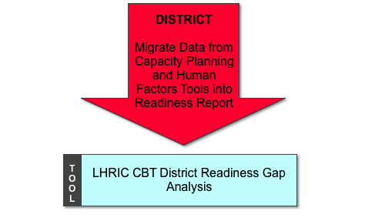

# III. The District Readiness Gap Analysis Report

(describe the purpose of this report and provide the report template)

* Summary (bulleted list of readiness by each of the following 5 categories)
* Devices
  + Benchmark/Assumptions (per PARCC guidelines)
  + Readiness statement (e.g., number of additional devices needed per school)
  + Discussion (alternative scenarios, possible remedies, etc.)
* Bandwidth
  + Benchmark/Assumptions (per PARCC guidelines)
  + Readiness statement (e.g., additional internal/external bandwidth required)
  + Discussion (alternative scenarios, possible remedies, etc.)
* Facilities
  + Benchmark/Assumptions (per PARCC guidelines)
  + Readiness statement (e.g., need for additional/alternative space, etc.)
  + Discussion (alternative scenarios, possible remedies, etc.)
* Staffing
  + Benchmark/Assumptions (per PARCC guidelines)
  + Readiness statement (e.g., need for additional staff, or staff reallocations on testing days)
  + Discussion (alternative scenarios, possible remedies, etc.)
* Other Issues (whatever these might be)
* Recommended Next Steps (discussion of what the district needs to do next to reach readiness)

# V. Attachments/Appendices

* PARCC Tool
* PARCC Guidelines
* List of Useful Links (e.g., conversion tools, state sites, etc.)
* Glossary of Terms