**Sun Associates Instructional Technology Program Review**

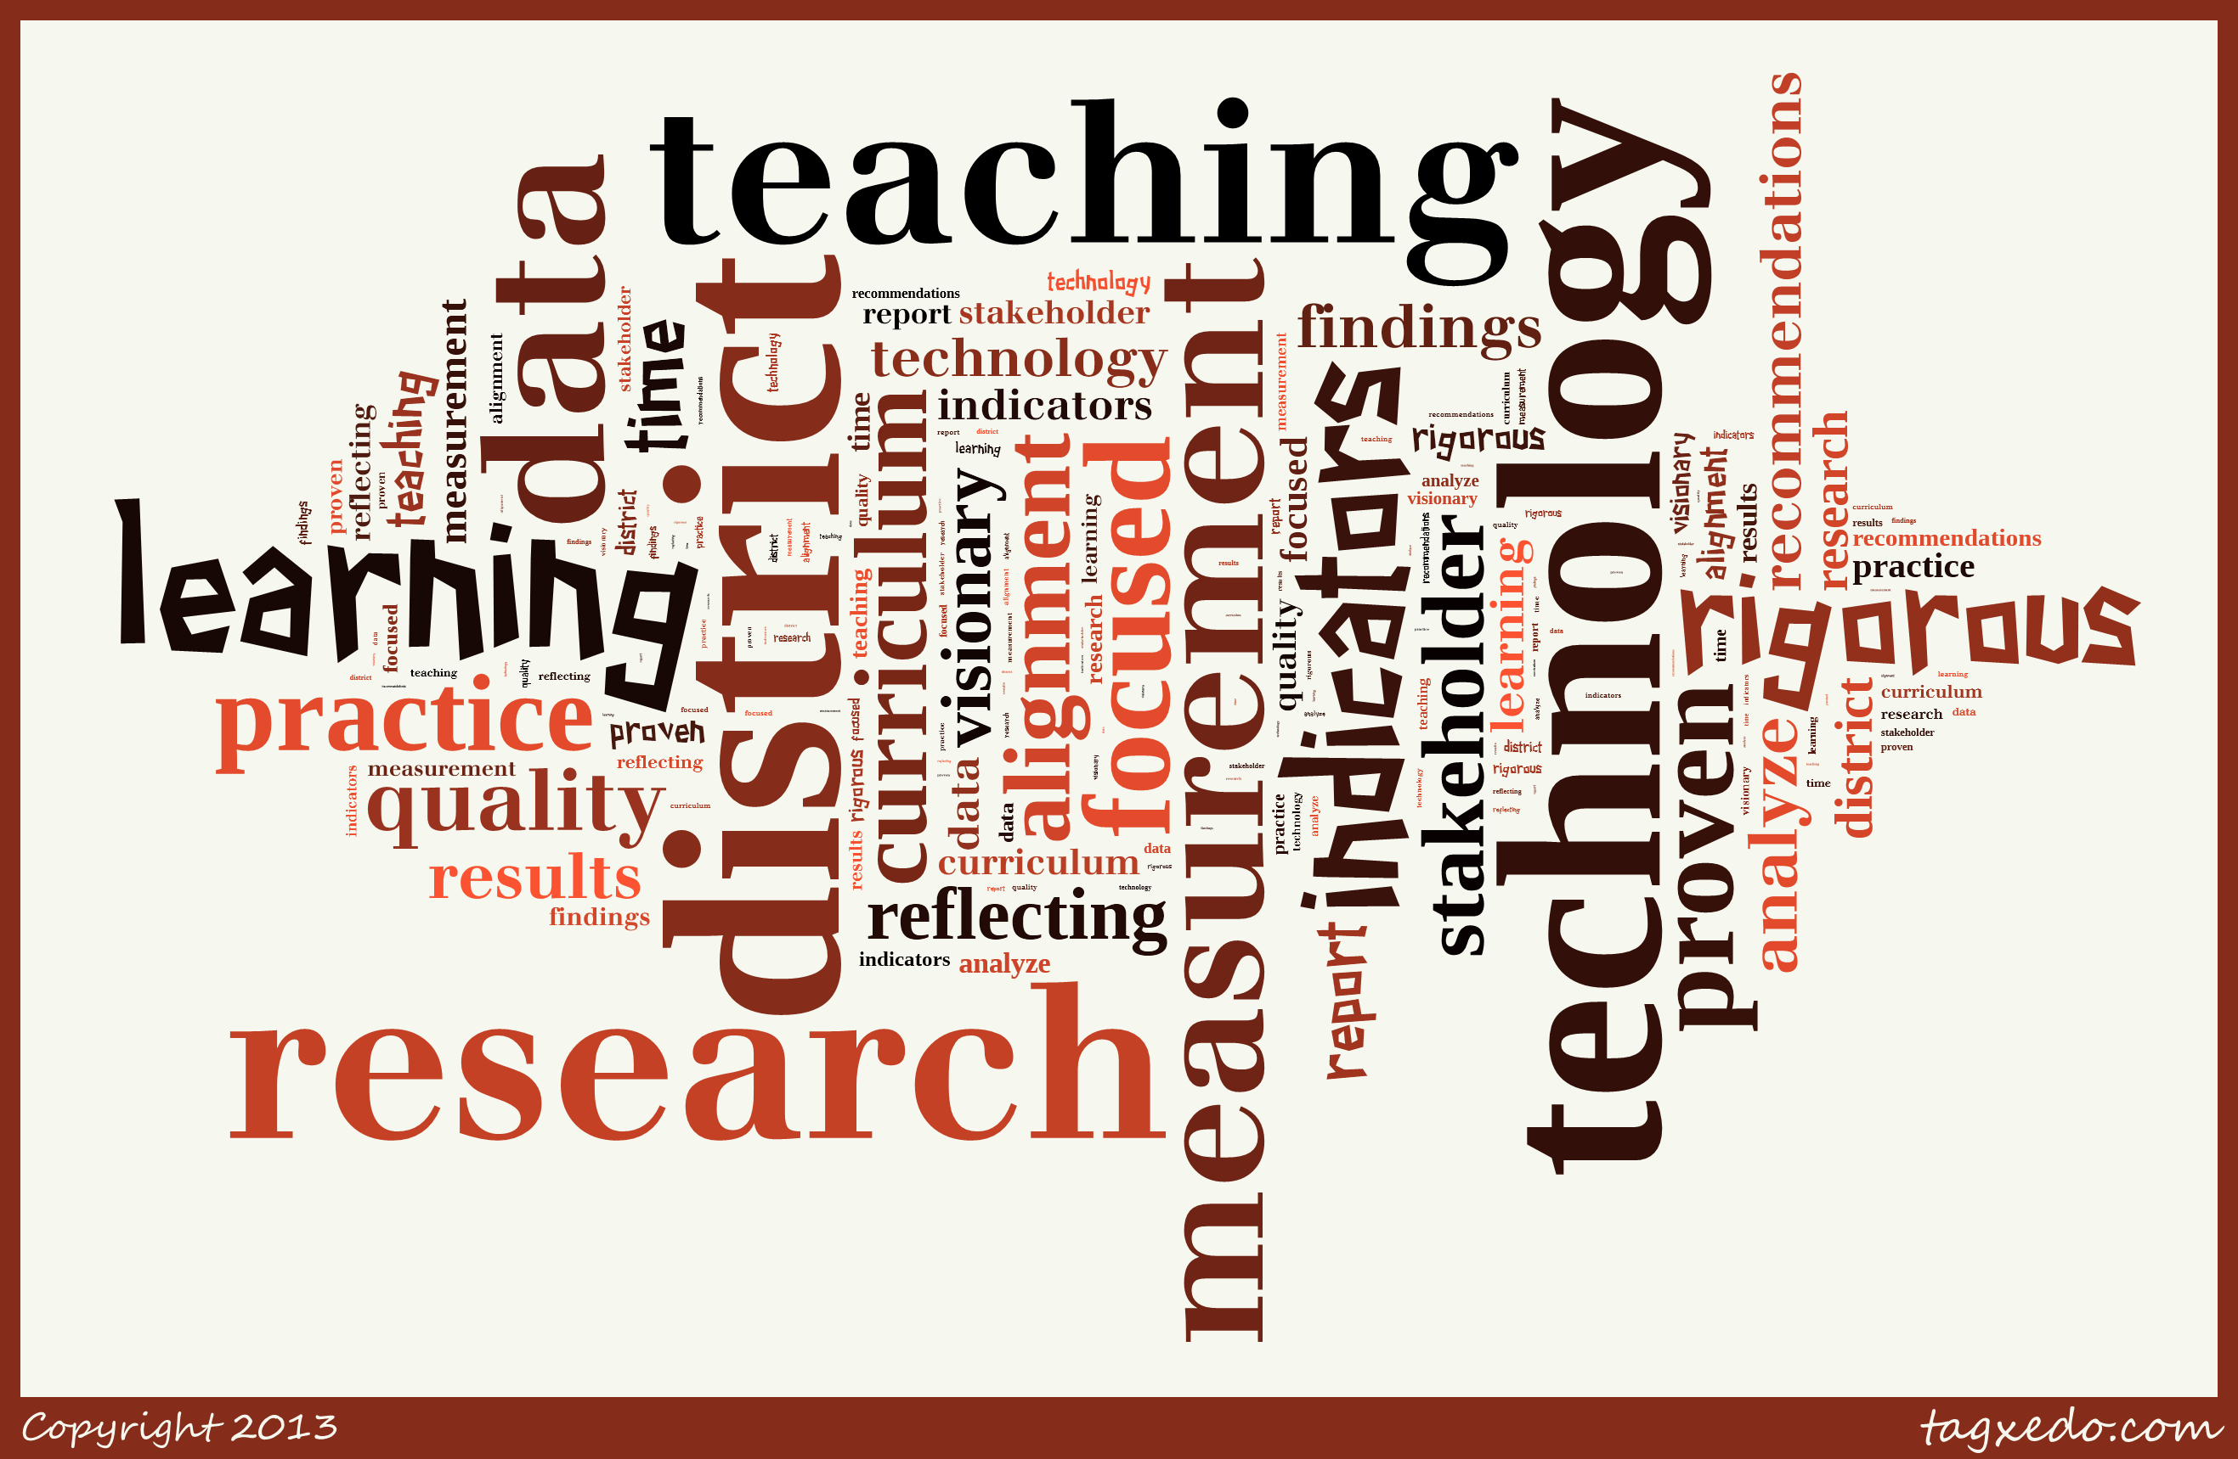

A Sun Associates Instructional Technology Program Review brings together K-12 district stakeholders in facilitated process to determine the extent to which the district is meeting its goals and objectives related to the use of technology to support teaching and learning.

**Benefits**

* *The Sun Associates Instructional Technology Program Review is a review of district teaching and learning practices related to the use and integration of instructional technology.*

At its core, the evaluation is about curriculum, learning, and instruction and how district practices can be improved to meet national standards for technology-supported teaching and learning. Issues of infrastructure capacity and design are part of the Review’s findings and recommendations, but in all cases curriculum and instruction drives decisions related to infrastructure. The end result is that the Review helps guide a district toward truly understanding the impact of technology on the learning environment.

* *The Technology Program Review process is designed to bring together teachers, administrators, students, and community members in a facilitated reflection on teaching, learning, and other student outcomes.*

The performance indicators developed through the process facilitated by Sun Associates have the buy-in of the stakeholders responsible for their development. The district community “owns” the Review results and the recommendations arising from the Review.

* *The Technology Program Review derives findings from data from multiple sources across the district and community.*

Typically, a Sun Associates Instructional Technology Program Review incorporates survey, interview, classroom observation, and focus group data. Data is collected from teachers, students, parents, administrators and community members.

* *A Sun Associates Technology Program Review incorporates up-to-date research and information on trends and best-practices related to technology-infused teaching and learning.*

Educators nationwide are seeing a convergence of standards and initiatives related to technology, the Common Core for Learning, STEM, local/state curriculum standards, and 21st century learning skills. A Sun Associates Technology Program Review helps a district see where these initiatives overlap and helps establish a common theme that ties these initiatives together.

**Process**

The Sun Associates Instructional Technology Review process typically takes the following course:

1. Sun Associates facilitates a team of district stakeholders in the development of unique performance indicators that will guide the Program Review.
2. Sun Associates creates a range of data collection instruments such as surveys, interview and observation protocol that align with the performance indicators.
3. Sun Associates sends a team of professional educational evaluators into the district to collect data from teachers, administrators, parents and students. Data is always collected via a variety of mechanisms intended to create a multi-faceted, triangulated, picture of district performance against the performance indicators.
4. Sun Associates compiles a detailed Program Review report that outlines the Review process, the indicators, and collected data along with findings and recommendations.
5. The Program Review report – with a focus on the findings and recommendations – is discussed with the district stakeholders who commissioned the Review. If the district desires, the Review report can be presented to the broader district community (e.g. School Board) through a professional presentation by Sun Associates staff.

**For further information on Sun Associates, please visit us online at www.sun-associates.com**